SINO-JAPAN CHEMICAL CO., LTD
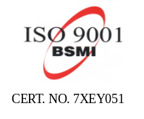

Head Office: 14 Fl. 99, Sec. 2 Jen Ai Road, Taipei, Taiwan. R. O. C.
TEL : 886-2-23966223 FAX : 886-2-23414628
http://www.sjc.com.tw

SPECIFICATION

I ITEM | SINONATE 290MH2
COMPOSITION | Di-Alkyl Sulfosuccinate
APPEARANCE | CLEAR LIQUID
Color | A-100 Max.
PH(1%aq) | 5-7
SO3 (%) | 12.3-13.0
Solid Content (%)(3g/130℃/30Min.) | 70-72
Specific Gravity(30℃) | 1.060-1.100
APPLICATION：EXCELLENT WETTING AND PENETRATING AGENT .

H.S CODE：3402.19.0000

